Modelling Using Quadratic Equations

y = ax² + bx + c y = a(x-b)² + c y = a(x-b)(x-c)

Problem 1: The curve of a suspended piece of string

You will model the curve of a suspended piece of string using a parabola and determine the corresponding quadratic equation.

Equipment: a piece of string 50–100cm long, sticky tape, a 1 metre ruler, two tables of the same height, graph paper.

Set up your piece of string between two tables to form a suspended curve. Use the tape to stick down the string on the table tops.

List the sort of measurements you think you will need to make to allow you to determine the equation of the curve of the string.

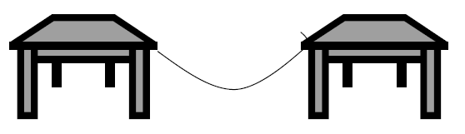

Use graph paper to draw up a set of axes and hand sketch the curve you are going to model.
Make the scales on both axes a 1:1 ratio, this means that if the distance between 0 and 1 is 1cm on the x axis it will also be 1cm between 0 and 1 on the y axis.

Label all important points on your graph. Give some thought to where you will place your curve in relation to the origin.

Now determine the equation of the curve of the string.

Problem 2: Footbridge
Parabolic arches have been used extensively in the construction of buildings and bridges over many years.

You are to design a wooden footbridge, whose curve is parabolic, to span a small creek 140 cm wide and determine the corresponding quadratic equation.

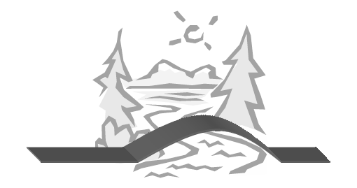

When designing your bridge you will need to give some thought to:

• the horizontal length of the bridge – how far from the banks of the creek will the bridge start?
• the height of the bridge – is it easy to walk over, not too steep.

Decide on the measurements of your bridge and write down your reasons for selecting them.

Use graph paper to draw up a set of axes and hand sketch the curve you are going to model.
Make the scales on both axes a 1:1 ratio, this means that if the distance between 0 and 1 is 1cm on the x axis it will also be 1cm between 0 and 1 on the y axis.

Label all important points on your graph. Give some thought to where you will place your curve in relation to the origin.

Now determine the equation of the curve of your bridge.

Problem 3: Path of a free falling ball

The paths of rocks falling from a cliff or a cannon ball being ejected from a cannon are parabolic.
You will model the path of a wet tennis ball being tipped off a vertical wall/fence/balcony and determine the corresponding quadratic equation.

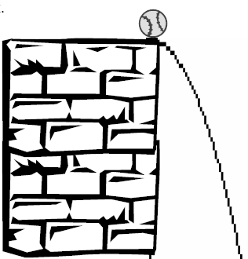
Equipment: a wet tennis ball, a tape measure, a vertical wall, such as a fence, balcony, second storey window, for which you can measure the vertical distance from the ground.

Very gently roll the wet tennis ball of the ledge, without throwing it or really pushing it. The place where it first lands on the ground should be easily identified from the water mark.

Now determine the equation of the path of the ball.

